Business objects:- estate property, property types/tags, property offers
Object views:-they’re the ui that allows for interaction with business objects we have form view and search view
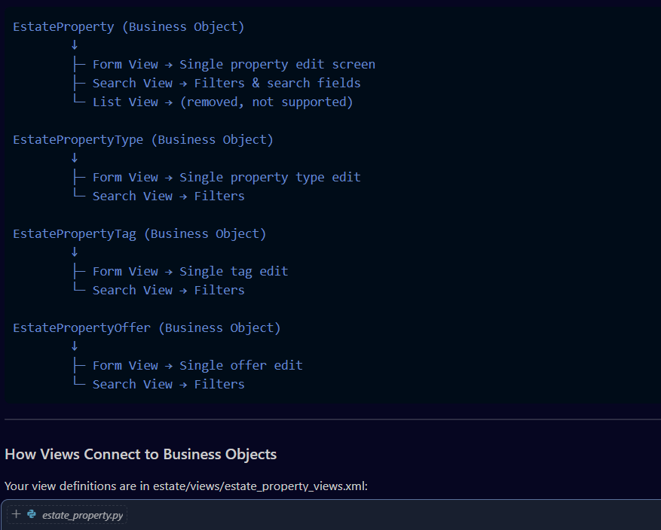
Controllers:- python classes that define http requests and define url routes, bridge between web interface and business objects
Your Estate Module Controllers
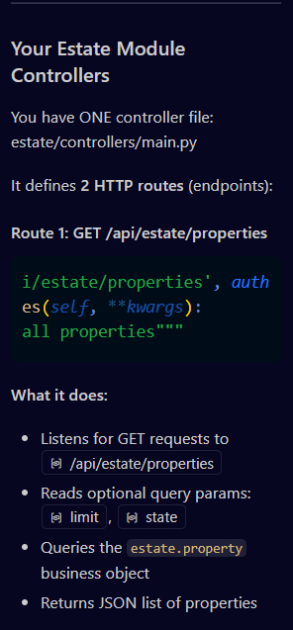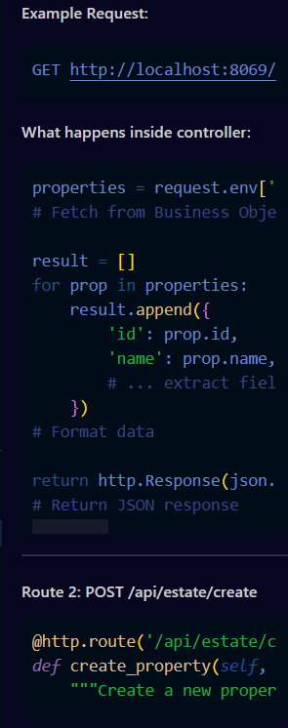
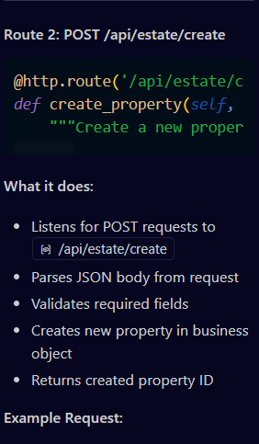data = json.loads(request.httprequest.get_data(as_text=True))
# Parse incoming JSON

property_obj = request.env['estate.property'].sudo().create({
'name': data.get('name'),
'expected_price': data.get('expected_price'),
# ... set fields
})
# Create record in Business Object (database)

return http.Response(
json.dumps({'success': True, 'property_id': property_obj.id}),
content_type='application/json'
)
# Return success responseYou have ONE controller file: estate/controllers/main.py
It defines 2 HTTP routes (endpoints):
Route 1: GET /api/estate/properties

What it does:
- Listens for GET requests to /api/estate/properties
- Reads optional query params: limit, state
- Queries the estate.property business object
- Returns JSON list of properti

